
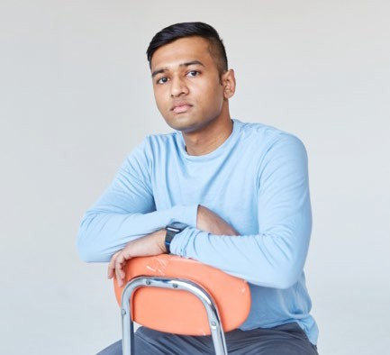


Prince Chowdhury
929-257-8853
Pc7845@rit.edu
Queens, NY 11372
Current courses
- Data Analytics and Business Intelligence
- Management of Innovation
- Diversity in Workplace
- Business Ethics
- Design and Information Systems
Extracurriculars
- HEOP Advisory board President: 2022-23 Vice President: 2021-22 Event Coordinator: 2020-21
- RIT Intramural Volleyball
- University Exploration Ambassador
- ALANA
- APICs Club (Supply Chain)
Licenses
- FAA Aircraft Powerplant License
Awards
- 7 Dean’s List
.

Objective
Seeking a full-time position for a leadership role within packaging industry.

Education
MBA | Business Administration
Rochester Institute of Technology, Rochester, NY Expected December 2024

Bachelor’s | Packaging Science
Rochester Institute of Technology, Rochester, NY Bachelor of Science
Minor: Business Administration GPA: 3.6
December 2023

Work History
GlaxoSmithKline Pharmaceutical Company Packaging Engineer
Raleigh NC, January 2022- July 2022
- Worked on a project to move to a smaller cc bottle for HIV Medicine
- Overlooked day-to-day problems relating to packaging on the production line
- Worked on a project involving leaks around bottle caps and found the cause using X-ray testing

Rochester Institute of Technology- Intramurals
Intramural Sports
Student Manager
Rochester NY, August 2021- Current
- Oversee intramural sports’ day-to-day operations
- Manage student referees
- Perform administrative duties

Amazon
Amazon Prime Student Brand Ambassador
Rochester, NY, January 2023- October 2023
- Be the campus representative for Amazon Prime Student
- Social media research and content creation
- Hold campus-wide events

Skills
Software: Microsoft Word, PowerPoint, Excel, SolidWorks, Illustrator, ArtiosCAD, Cape
Personal: Motivated, Organized, Time management, People skills, Problem solving
Language: English, Bangla, Basic Hindi

